Multiple-choice section – choose the correct answer

Question 1 [2.3]

The hypotenuse of a right-angled triangle is 17 cm in length. One of the shorter sides is 16 cm. What is the value of the third side?

A cm B cm C 11 cm D cm

Question 2 [2.1]

Which of the following statements is true?

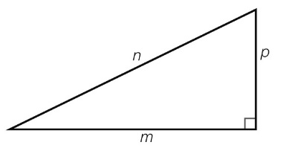

A *m*2 + *n*2 = *p*2 B  C  D *n*2 – *m*2 = *p*2

Question 3 [2.5]

If *a* = 12 and *b* = 16, and *a*, *b* and *c* form a Pythagorean triple, what is the value of *c*?

A 22 B 21 C 18 D 20

Question 4 [2.2]

Calculate the length of the hypotenuse to 2 decimal places.

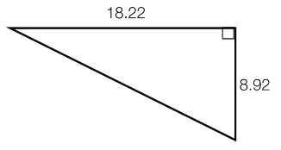

A 20.28 B 15.88 C 20.29 D 15.89

Question 5 [2.2]

Which statement about  is *not* correct?

A  is a surd. B  is a rational number. C  is approximately 2.45. D = 6

Question 6 [2.4]

A ladder leans against a vertical wall. The ladder is 2.5 metres long and its base is 1.5 metres from the bottom of the wall. If the ladder is moved so that its base is only 1 metre from the base of the wall, which one of these statements is true?

A A calculation using Pythagoras’ theorem is needed to find the new height of the top of the ladder.

B The top of the ladder is now 2 m above the ground.

C The height of the top of the ladder is decreased by 0.5 m.

D The height of the top of the ladder is increased by 0.5 m.

Question 7 [2.2]

What is the value of the diagonal to 2 decimal places?

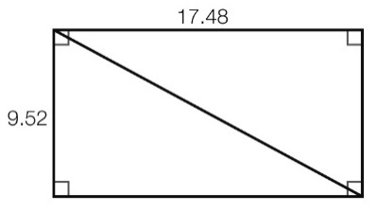

A 7.96 B 14.66 C 19.90 D 20.33

Question 8 [2.5]

Which one of the following sets of numbers forms a Pythagorean triple?

A (2, 4, 6) B (7, 24, 25) C (13, 14, 15) D (8, 9, 15)

Multiple-choice results: ___ / 8

Short answer section

Question 9 3 marks [2.1, 2.2, 2.5]

Use words from the list below to complete the following sentences. (A word may be used more than once.)

hypotenuse right-angled triangle Pythagorean triples surd theorem   
irrational longer shorter approximate exact

**(a)** In a right-angled triangle, the _________________ is the side opposite the right angle.

**(b)** To find the length of the ______________, we take the square root of the sum of the squares of the two _______ sides.

**(c)** By showing that the numbers in ______________ satisfy Pythagoras’ ________, we show that these numbers could represent the lengths of sides of a _________________.

Question 10 3 marks [2.4]

Bill and Jan both attempt to use Pythagoras’ theorem to calculate the value of *k* in the following diagram. Their working is shown below.

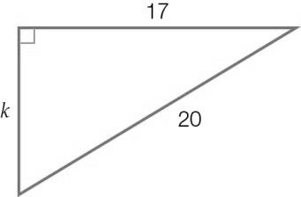

**(a)** Find the incorrect step(s) in each solution. Circle the lines of working that are incorrect.

Bill: 172 + 202 = *k*2 Jan: 202 – 172 = *k*

289 + 400 = *k*2 32 = *k*2

689 = *k*2 9 = *k*2

= *k*  = *k*

*k* = 26.25 *k* = 3

**(b)** Explain the mistakes that each has made.

Bill:

_________________________________________________________________________

_________________________________________________________________________

Jan:

_________________________________________________________________________

_________________________________________________________________________

Question 11 2 marks [2.1]

Which of the following triangles contains a right angle? Use the converse of Pythagoras’ theorem to justify your answer.

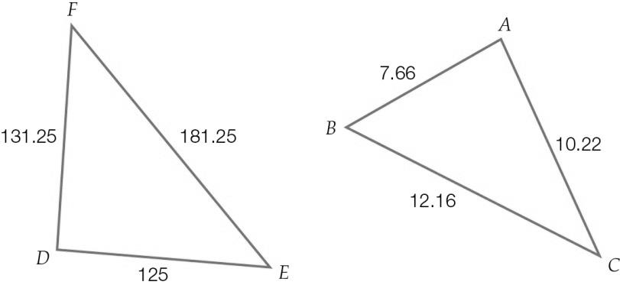

Question 12 2 marks [2.1]

Write an appropriate statement of Pythagoras’ theorem (in the form of an equation) for the following triangles.

**(a) (b)**

|  |  |
| --- | --- |
|  |  |

Question 13 1 mark [2.1]

Use a ruler to construct a right-angled triangle with side lengths of 5 cm, 3 cm and 4 cm. Label the hypotenuse and the right angle.

Question 14 2 marks [2.2]

Determine the value of the pronumeral in this triangle, to 2 decimal places.

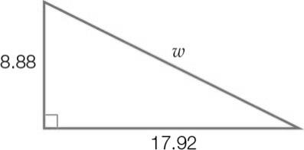

Question 15 2 marks [2.2]

Find the length of the hypotenuse in exact (surd) form.

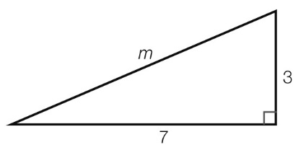

Question 16 2 marks [2.3]

Find the value of the unknown side in this right-angled triangle, to 2 decimal places.

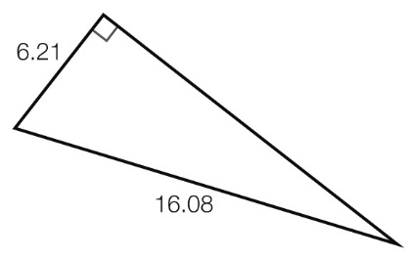

Question 17 2 marks [2.3]

Find the value of the pronumeral in the following right-angled triangle, in exact (surd) form.

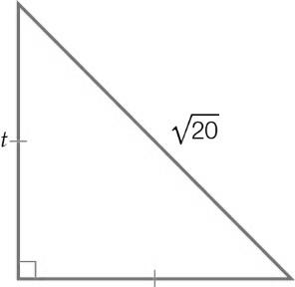

Question 18 2 marks [2.3]

Find the value of *v* in the following diagram, correct to 2 decimal places.

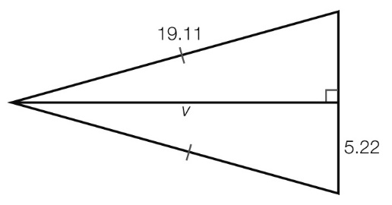

Question 19 3 marks [2.4]

A ladder of length 2.1 m is leaning against the wall. Its base is 0.9 m from the wall. A picture is hanging at a height of 1.92 m. What is the difference between the height of the ladder and the height of the picture? (Give your answer in centimetres, to the nearest whole number.)

Question 20 3 marks [2.4]

A pole is supported by two wires, each of length 17 m, which are pegged to the ground as shown. Assume that a straight line can be drawn from peg to peg and that the pole is located at the midpoint of this line. The pole is 15 m high. What is the distance between the two pegs?

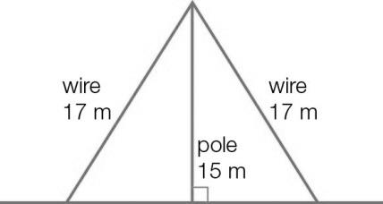

Question 21 2 marks [2.5]

Replace the pronumeral with a positive integer to form a Pythagorean triple.

(a) (5, 12, *h*) (b) (9, *b*, 41)

Question 22 2 marks [2.5]

Using Pythagoras’ theorem, determine whether or not the following sets of numbers could be classified as Pythagorean triples.

(a) (10, 60, 61) (b) (12, 35, 37)

Short answer results: ___ / 31

Extended answer section

Question 23 5 marks [2.1]

Kimmy is renovating her house and wants to check that her plan for one of her rooms is ‘square’. She measures the length of the room’s floor as 3.1 m, the width as 3.7 m, and the diagonal across the room as 4.9 m.

(a) Sketch a diagram (scale is not important) to represent the floor plan of the room in question.

(b) Use the converse of Pythagoras’ theorem to show that Kimmy’s room is not ‘square’.

(c) Suggest how Kimmy can adjust the length, the width and the diagonal on the plan to ensure that they meet at right angles. Use calculations to show that your answer will ensure that the room is ‘square’.

Question 24 9 marks [2.2, 2.4]

John walks from the train station (point *A*) to his house (point *B*): he walks 800 m east, 1.2 km north and then 300 m east. Annabelle walks from her house (point *C*) to the train station (point *A*). To do this, she walks 500 m north, 1 km west and then 200 m north.

(a) Draw a diagram (scale is not important) to represent the journeys of John and Annabelle.

(b) Calculate the total distance John walks. Calculate the total distance Annabelle walks. Who walks further and by what length?

(c) If a straight line is drawn from point *A* to point *B*, what is the length of this line?

(d) If a straight line is drawn from point *C* to point *A*, what is the length of this line?

(e) Use your previous two answers to determine who lives closer to the station and by what distance.

Question 25 5 marks [2.5]

(a) Find new Pythagorean triples by doubling each of the numbers in the following sets.

(i) (6, 8, 10) (ii) (20, 21, 29)

(b) Find new Pythagorean triples by completing the following table.

|  |  |  |  |
| --- | --- | --- | --- |
| *b* | ( *b*2– 1) | ( *b*2+ 1) | Triple |
| 9 |  |  |  |
|  | 60 |  |  |

(c) Find new Pythagorean triples by completing the following table.

|  |  |  |  |  |  |
| --- | --- | --- | --- | --- | --- |
| *g* | *h* | *g* + *h* | *gh* |  | Triple |
| 1 | 3 |  |  |  |  |
| 3 | 5 |  |  |  |  |

Extended answer results: ___ / 19

TOTAL test results: ___ / 58